Prelude
or
What The Sirens Sing…
or
When The Flute-Girl Plays for the Women

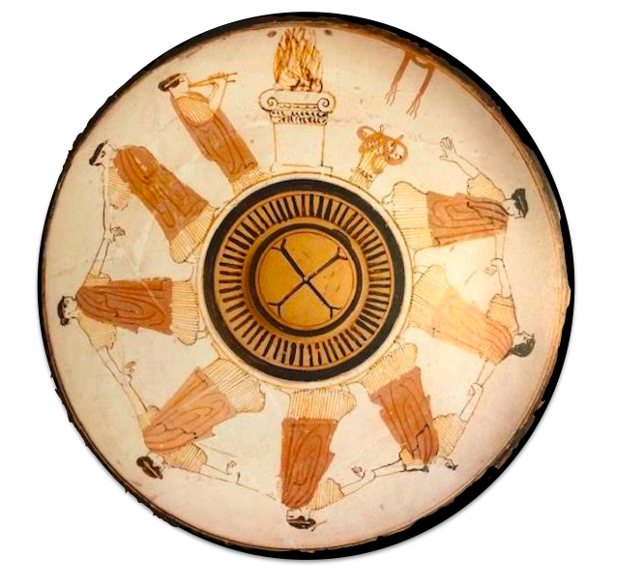
Attic white-ground phiale, the Painter of London D12. Boston, Museum of Fine Arts 65-908
ca. 450BCE

In the ethno-poetics and performance of the shaman, my people, the Indians, did not split the artistic from the functional, the sacred from the secular, art from everyday life. The religious, social and aesthetic purposes of art were all intertwined. Before the Conquest, poets gathered to play music, dance, sing and read poetry in the open-air places around the Xochicuahustl, el Arbol Florido, Tree-in Flower. (The Coaxihuitl or morning glory is called the snake plant and its seeds, known as ololiuhqui, are hallucinogenic.) The ability of story (prose and poetry) to transform the storyteller and the listener into something or someone else is shamanistic. The writer, the shape-changer, is a nahual, a shaman.
- Gloria Anzaldúa, La Frontera

The erotic is a resource within each of us that lies in a deeply female and spiritual plane, firmly rooted in the power of our unexpressed or unrecognized feeling. In order to perpetuate itself, every oppression must corrupt or distort those various powers within the culture of the oppressed that can provide energy for change. […] Our erotic knowledge empowers us, becomes a lens through which we scrutinize all aspects of our existence, forcing us to evaluate those aspects honestly in terms of their relative meaning within our lives. And this is the grave responsibility, projected from within each of us, not to settle for the convenient, the shoddy, the conventionally expected, nor the merely safe.
- Audre Lorde, Sister Outsider
.

When I was young the story of my people was told twice: once by my parents, then again by my schoolteachers. From my ‘ohana (family), I learned about the life of the old ones: how they fished and planted by the moon; shared all the fruits of their labors, especially their children; danced in great numbers for long hours; and honored the unity of their world in intricate genealogical chants. […] At school, I learned that the “pagan Hawaiians” did not read or write, were lustful cannibals, traded slaves and could not sing.
— Haunani-Kay Trask, From a Native Daughter

Agonistic travellers fail consistently in their attempt to travel because what they do is to try to conquer the other “world”. That is what assimilation is all about. Assimilation is the destruction of other people’s “worlds”. So, the agonistic attitude, the playful attitude given western man’s construction of playfulness, is not a healthy, loving attitude to have in traveling across “worlds”. Notice that given the agonistic attitude one cannot travel across “worlds,” though one can kill other “worlds” with it. So for people who are interested in crossing racial and ethnic boundaries, an arrogant western man’s construction of playfulness is deadly. One cannot cross the boundaries with it. One needs to give up such an attitude if one wants to travel.
— Maria Lugones, “Playfulness, “World”-Travelling and Loving Perception”

It is a divine affair, this engendering and bringing to birth, an immortal element in the creature that is mortal. […] Every mortal thing is preserved in this way; not by keeping it exactly the same forever, like the divine, but by replacing what goes off or is antiquated with something fresh, in the semblance of the original.
— Diotima, Plato’s Symposium 206c and 208b (trans. Lamb)

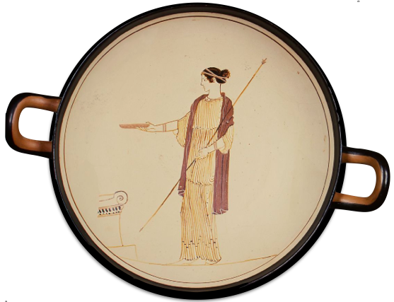

Attic white-ground cup, the Villa Giulia Painter. New York, Metropolitan Museum of Arts
ca. 470BCE

Platonic Priestesses: Erotic Pedagogy Heard Through the Song of the Sirens
Danielle A. Layne
Gonzaga University

I. Introduction

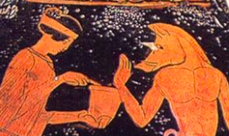
So, it all came to pass. Well listen now to what I tell you, and let some god remind you of it. Next you will come to the Sirens who beguile all men that approach them. Whoever encounters them unawares and listens to their voices will never joy at reaching home, his wife and children to greet him. Instead the Sirens’ tempt him with their limpid song, as they sit there in the meadow with a vast heap of moldering corpses, bones on which hangs the shriveled skin.
- Circe, Homer’s Iliad Book XII (trans. Kline)

The Sirens
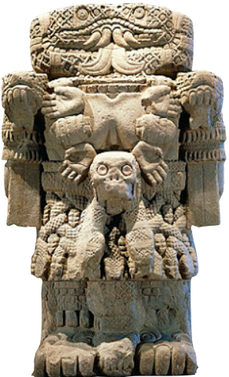
Gloria Anzaldúa, Chicana Feminist who writes of mestiza consciousness as that which must “continually walk out of one culture and into another”. It is a state of being which must learn to flourish in a world of ambiguity and contradiction, of constant adaptation. Anzaldúa invokes the goddess Coatlicue (right: Serpent Skirt, ca. 1250CE, National Museum of Anthropology, Mexico City) Coaticue is the “voice at the edge of things,” that demands fierce transformation: “But I know what I want and I stamp ahead, arrogance edging my face. I tremble before the animal, the alien, the sub-or suprahuman, the me that has something in common with the wind and the trees and the rocks, that possesses a demon determination and ruthlessness beyond the human.” (1987, 50).

Audre Lorde, Black Feminist Poet and Prose writer wrote “The erotic is a measure between the beginnings of our sense of self and the chaos of our strongest feelings”; it is the “internal requirement toward excellence” from which our creative energies and works “rise up empowered” “reclaiming in our language, our history, our dancing, our loving, our work, our lives.” (1984/2007, 54 and 56).

Huanani-Kay Trask, Native Hawaiian political scientist and author of Eros and Power: The Promise of Feminist Theory who argued that the Western tradition writes of its own culture when writing of hers: “When historians wrote that the king owned the land and the common people were bound to it, they were saying that ownership was the only way human beings in their world could relate to the land […]. And when they said that our chiefs were despotic, they were telling of their own society, where hierarchy always results in domination. […] And when they wrote that we were superstitious, believing in mana of nature and people, they meant that the West has long since lost a deep spiritual and cultural relationship to the earth.” (1993, 118).

Maria Lugones, Argentinian pluralistic feminist who argued for a methodology focused on loving perception and authentic “world”-traveling whereby "Love is seen not as fusion and erasure of difference, but as incompatible with them. Love reveals plurality," (1987, 3) and “world”-traveling is a methodology for examining “Playfulness is, in part, an openness to being a fool, which is a combination of not worrying about competence, not being self-important, not taking norms as sacred and finding ambiguity and double edges a source of delight. [It is an] openness to self-construction or reconstruction and to construction or reconstruction of “worlds” we inhabit playfully. […] In attempting to take hold of oneself and one’s relation to others in a particular “world”, one may study, examine and come to understand oneself.” Lugones (1987, 17)

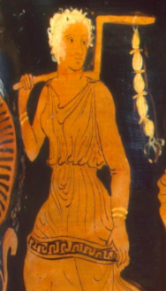
II. Diotima
Clothing: For information on the dress wear of priestesses see Connelly (2007, 90-92). She argues persuasively that at most temples priest and priestesses were required to wear white. However, at Eleusis (which Plato clearly associates with Diotima [see below]) there was an exception as sacred officials were required to wear the color purple. See Lysias, Against Andokides 51 where the priests shook their “purple cloaks” at Andokides for participating in Alcibiades’ parody of the Mysteries. Finally, Diotima’s shoes reflect the fact that priestesses were most like restricted to utilizing only the skins of sacrificial animals. Temple Key: See Connelly (2007, 92) who argues “The surest signifier of feminine priestly status in visual culture is the temple key. […] The iconography of the female kleidouchos is established by the late sixth or early fifth century BC.” (right, Southern Italian krater, The State Hermitage Museum, St. Petersberg)

Two Common Methods for Researching Women (like Diotima) in Antiquity
Inclusivist Influenced by the aims of 1st Wave Feminism, e.g. equality and fair representation.
Mary Ellen Waithe, A History of Women Philosophers: Volume I :“By providing the educator with new material for the classroom teaching of the history of philosophy, and women’s history, we hope to generate a new awareness of women’s contributions to our own intellectual heritage.” (1987, xi) “[W]e find little differences in the ways men and women did philosophy. Both have been concerned with ethics, metaphysics, cosmology, epistemology and other areas of philosophical inquiry.” “These women are not women on the fringes of philosophy, but philosophers on the fringes of history.” (1987, xxii and xxi).
Deconstructivist Influenced by the aims of 2nd Wave Feminism, e.g. promoting the dismantling of power structures that either a) devalue the feminine in the guise of Otherness, Plurality, Difference, Emotions, Embodiment, etc. and/or b) silence/erase the reality of the feminine/woman outside of patriarchal systems (authentic Otherness outside the masculine imaginary).
Luce Irigaray, “Sorcerer’s Love: A Reading of Plato’s Symposium“ (1994, 181), “In the Symposium, the dialogue on love, when Socrates finishes speaking, he gives the floor to a woman: Diotima. She does not participate in these exchanges or in this meal among men. She is not there. She herself does not speak. Socrates reports or recounts her views. He borrows her wisdom and power, declares her his initiator, his pedagogue, on matters of love, but she is not invited to teach or to eat. Unless she did not want to accept the invitation? But Socrates says nothing about that. And Diotima is not the only example of a woman whose wisdom, above all in love, is reported in her absence by a man. David Halperin, “Why is Diotima a Woman?” (1984, 289 and 297): “To study the various strategies by which men simultaneously construct and co-opt female “difference,” in other words, is not at all to study men’s attitudes toward (real) women; rather it is to study the male imaginary, the specular poetics of male identity and self-definition. […] If Diotima is not a woman but a “woman,” it no longer makes any sense to inquire into her gender. For “woman,” too, turns out to be a trope: in the representational economy of Plato’s text (as elsewhere), “woman” is always a sign of something else—of spurious sexual difference that men (as they see themselves once lack and possess”. “[…] Diotima is an effect of Sokratic ventriloquism.” (293) See also Freeman’s (1986) argument that Diotima is just Plato in drag or DuBois’ (1988) classical argument that Plato appropriated Diotima to coopt women’s reproductive power, e.g. men suffer from womb anxiety and thus desire to develop a purely masculine form of reproduction.
Against Deconstructivist Approaches
Crystal Addey, “Diotima, Sosipatra and Hypatia: Methodological Reflections on the Study of Female Philosophers in the Platonic Tradition” (forthcoming): “The danger of post-structuralist critiques … is that the historical presence and contributions of “real women” in the ancient world may be obscured, undermined or entirely elided – in other words, this kind of post-structuralist interpretation could be seen as a hermeneutic strategy that effectively writes women out of history. Consequently, such hermeneutic approaches may contribute to the reification and reinforcement of patriarchal structures that elide, downplay or marginalise women’s intellectual activities and contributions, ancient and modern.”

Using Anzaldúa, Lorde, Trask, Lugones: How might a 3rd wave feminist approach allow for a different way into antiquity and the status of women? Trask might ask, how are these common methodologies reflecting contemporary needs? How might I, as Lugones demands, “world”-travel so as to inquire into the status of Diotima as priestess and mystagogue?

Plurality of Priesthood roles for Women (see Connelly 2007, 31-46)
- Childhood arrephoroi, aletris, bears of the Brauronia sanctuary, hearth initiates at the Eleusinian Mysteries, etc.
- Maidenhood 1) kanephoroi, leaders in processions, basket-carriers, etc. given to honor and reinforce the stature of particular high-ranking families; 2) Virgin Priestess or sacred service roles at temples or sanctuary, erigastini, plyntria, hydrophoros, kleidophoros,, loutrophoros (temporary positions before marriage; “…many of these priestesses were descended from women who had also held the office, illustrating that virginity was considered a phase rather than a lifelong condition of those who served.” Connelly 2007, 41)
- Maturity hierophantidai, kosmesis, epikosmesis, antletriai, archousai, thiasoi married women, typically inherited priesthoods, one could hold positions interchangeably over their lifetime
- Advanced Age hiereia, hosioi, gerarai (“…postmenopausal and widowed women who composed the final age-class of cult service enjoyed enormously active roles. Their posts ranged from the prominent celibate priesthoods of Apollo at Delphi, Aphrodite at Sikyon, Artemis Hymnia at Orchomenos and Sosipolis at Olympia, to a full range of subpriestly positions in which they served alone or in groups.” Connelly 2007, 43)
Most priesthoods given on the basis of pedigree, financial status, beauty, inheritance, allotment, election and were often purchased. Most women from prominent social classes participated in some form of priestly activity at least once in their life but more often several times.
- Mantis, prophetes, promantis At Delphi most evidence indicates maidens from the peasantry class were chosen to fulfill this important role. There is generally agreement that due to threats of rape, the post came to be filled by older women. The Pythia could have been married with children but would remain chaste once she took up the post.
- Mustai, epoptai Mystagogues at festivals like the Eleusinian Mysteries (see below).

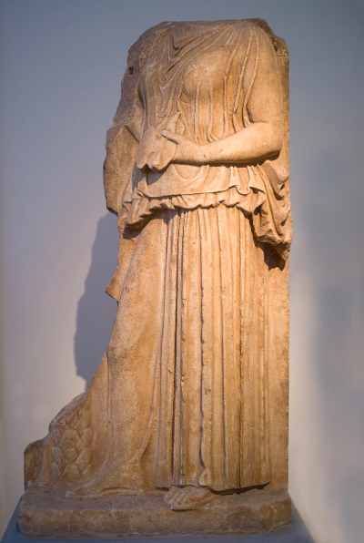
The Eleusinian Mysteries and Diotima’s Role as Mystagogue
Nancy Evans, “Diotima and Demeter as Mystagogues in Plato's Symposium” (2006) “Just as Demeter first initiated the Eleusinians, and each Eleusinian initiate (mustes) had a mystagogue, so Diotima serves as a mystagogue for Socrates, and, by extension, Socrates serves as mystagogue for the others at Agathon’s symposium, and even for us. When the more advanced epoptai and the first-time Eleusinian initiates (mustai), accompanied by their mystagogues, all met together into the Telesterion on the night of the Mysteries, all saw something that forever changed their conception of the world and their place in it. The experience at Eleusis was something above all intensely visual, and certainly passive. The initiates (mustai), the mystagogues, and the watchers (epoptai) took part in the Eleusinian rites, and saw something that took the terror out of human mortality. Likewise with Diotima’s initiation of Socrates.” (2006, 19) “The initiate into Diotima’s rites is led by someone else who knows the way and is able to lead rightly (ho hegoumenos, 210a6–7). […] Diotima here plays on the meaning of the word hegeomai, a verb that means “lead,” as well as “think, consider.” The word play here is subtle, but indicates an important shift. In the first instance, the one leading the initiate (ho hegoumenos) is the grammatical subject: the leader conducts the initiate lover through the rites of love (210a6–7). But once the initiate lover recognizes that the beauty of one is akin to the beauty of others, it is the initiate who becomes the subject (210b3; 210b6, 7). With this switch of subject, the meaning of hegeomai slips, and instead of meaning “lead” as it did at 210a6 and 7, in 210b it means “think, consider.” The leader drops out after a certain point, and the initiate continues alone on the journey to the vision of true Being.” See also Schefer (2003, 192). (left, Relief National Archaeological Museum, Athens, ca. 420)
Using Trask, how might Diotima’s role as mystagogue capture the value of a form of intellectual transmission that is personal and transformative, that cannot be captured by being written down but must be passed from one generation to the next in certain activities (Trask uses examples like songs, dance, etc.)? Using Lugones, how might Diotima enact a kind of loving, playfulness in her form of instruction/pedagogy that guides students to their own empowerment that further invokes Lorde’s conception of the erotic?

Women’s Power as Priestesses (the following is based on Connelly 2007)
Within the busy sacred calendar of Greek city-states, priestesses had numerous day-to-day obligations and responsibilities, holding much executive power and cultural capital in a time in which there is little to no distinction between the sacred and the secular. Examples: priestesses arranged festivals, the details of whom would take part, judging the holiness of certain performances/activities; arranging and caring for the arrephoroi; supervised temple construction/dedications as well as maintenance; oversaw and performed major initiation procedures/rites as well as sacrifices; they took part in preserving and reproducing religious documents/stories; they had absolute power to allow or deny entrance to particular temples or rites; they are often attested to have power over generals and kings from personal questions (about children) to major political action, etc.
What was Diotima’s power/authority status in comparison to Phaedrus (wealthy youth, eventually exiled for profanity of the Mysteries), Pausanius (legal expert), Erxyimachus (physician), Aristophanes (comedian), Agathon (tragic poet) and Socrates (philosopher)?

Rethinking Diotima’s Hierarchy of Progeny/Ladder of Love (208e-212a)
- Reproduction (likely Diotima would have, at one time, been married with children);
- Virtue, a requisite for priestesses;
- Oversaw/Created poetry, artistry in general for festivals;
- Crafting/Regulating/Enforcing holy laws;
- Philosophical Discursive Wisdom (as indicated by her refutation of Socrates);
- Sight of the Beautiful (as the mystagogue of such mysteries she purifies, initiates and reveals what she would have seen/known herself).

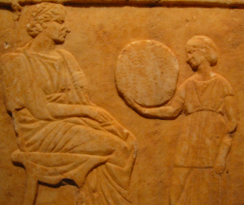
III. Neoplatonic Priestesses

Sosipatra of Ephesus (early 4th century AD) preserved in Eunapius, Lives of the Philosophers and Sophists, trans. Wilmer Cave Wright (Cambridge, MA and London, 1921).
Eunapius’ Praise: “Sosipatra, who by her surpassing wisdom made her own husband seem inferior and insignificant. So far did the fame of this woman travel that it is fitting for me to speak of her at greater length, even in this catalogue of wise men.” (right, Stele of priestess Chairestrate, Piraeus Museum, ca. 4th century BC)

The Chaldean priests prophesize to her father that she will become: “but one far above you and your way of life, a gift whereof the fame shall reach the skies and touch the stars, hand over this child Sosipatra to us who are more truly her parents and guardians, […] your daughter shall have a mind not like a woman's or a mere human being's."

Maturity: “And as she grew to the full measure of her youthful vigor, she had no other teachers, but ever on her lips were the works of the poets, philosophers, and orators; and those works that others comprehend but incompletely and dimly, and then only by hard work and painful drudgery, she could expound with careless ease, serenely and painlessly, and with her light swift touch would make their meaning clear. Then she decided to marry. Now beyond dispute Eustathius of all living men was alone worthy to wed her. So she said to him and to those who were present: "Do you listen to me, Eustathius, and let those who are here bear me witness: I shall bear you three children, and all of them will fail to win what is considered to be human happiness, but as to the happiness that the gods bestow, not one of them will fail therein.”

Renowned for Her Teaching: “After the passing of Eustathius, Sosipatra returned to her own estate, and dwelt in Asia in the ancient city of Pergamon, and the famous Aedesius loved and cared for her and educated her sons. In her own home Sosipatra held a chair of philosophy that rivalled his, and after attending the lectures of Aedesius, the students would go to hear hers; and though there was none that did not greatly appreciate and admire the accurate learning of Aedesius, they positively adored and revered the woman's inspired teaching. […]"

Her Own Need: When Philometor is with me he is simply Philometor, and in no way different from the crowd. But when I see that he is going away my heart within me is wounded and tortured till it tries to escape from my breast. Do you exert yourself on my behalf," she added, "and so display your piety." When he had heard this, Maximus went away puffed up with pride as though he were now associating with the gods, because so wonderful a woman had put such faith in him.”

How might I interpret Sosipatra through the methodologies of Anzaldúa as one who lives in a borderland, between two worlds or as encompassing Audre Lorde’s erotic or Lugones’ “willingness to be a fool”?

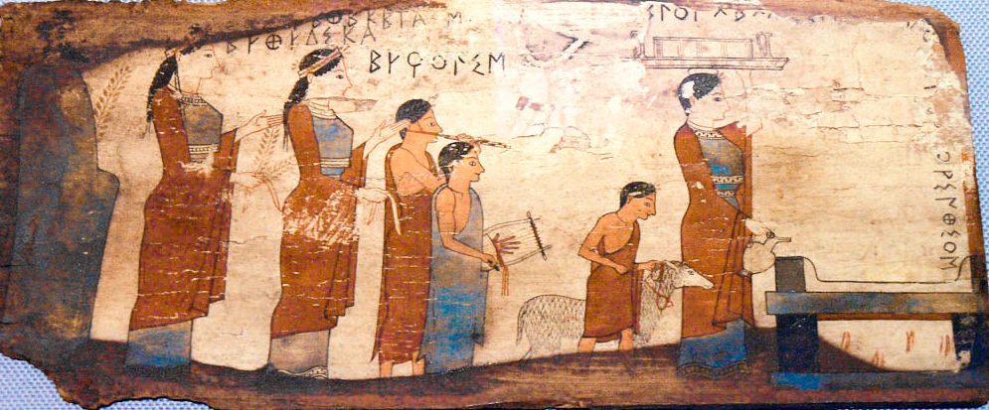
Painted wooden plaque, National Archaeological Museum ca. 530BCE

Theodora and Kallixeine (Priestesses Appointed by Julian, late 4th AD)
The Works of the Emperor Julian, volume III, trans. Wilmer Cave Wright, (Harvard UP, Loeb Classical Library, 1913)
Letter 32 to Theodora: I have received through Mygdonius the books that you sent me, and besides, all the letters of recommendation that you forwarded to me throughout the festival. Every one of these gives me pleasure, but you may be sure that more pleasant than anything else is the news about your excellent self, that by the grace of the gods you are in good physical health, and are devoting yourself to the service of the gods more earnestly and energetically. As regards what you wrote to the philosopher Maximus, that my friend Seleucus is ill-disposed towards you, believe me that he neither does nor says in my presence anything that he could possibly intend as slandering. […] But since you have made so many accusations against him, and have plainly revealed to me a definite cause for your own hostility towards him, I do say this much to you frankly; if you are showing favor to any person, man or woman, slave or free, who neither worships the gods as yet, nor inspires in you any hope that you may persuade him to do so, you are wrong. […]
Letter 34 to Theodora: I have received from you who are wisdom itself your letter telling me of the fair and blessed promises and gifts of the gods to us. First I acknowledged the great gratitude that I owed to the heavenly gods, and in the second place I rendered thanks to your generosity of soul, in that you are zealous, no one more so, in entreating the gods on my behalf […].
Letter 42 to Kallixeine: "Time alone proves the just man,"[as we learn from men of old; but I would add the god-fearing and pious man also. However, you say, the love of Penelope for her husband was also witnessed to by time. Now who would rank a woman's piety second to her love for her husband without appearing to have drunk a very deep draught of mandragora? And if one takes into account the conditions of the times and compares Penelope, who is almost universally praised for loving her husband, with pious women who not long ago hazarded their lives; and if one considers also that the period was twice as long, which was an aggravation of their sufferings; then, I ask, is it possible to make any fair comparison between you and Penelope? Nay, do not belittle my praises. All the gods will requite you for your sufferings and for my part I shall honor you with a double priesthood. For besides that which you held before of priestess to the most venerable goddess Demeter, I entrust to you the office of priestess to the most mighty Mother of the gods (see below) in Phrygia at Pessinus, beloved of the gods. (left, relief of priestess with initiates/assistants, ca. 320 BCE)
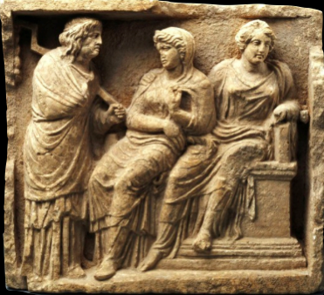
How might I interpret these two priestesses via Lugones’ concept of loving perception and Trask’s surviving colonization?

Asklepigenia of Athens (ca. 430-485AD), Marinus, The Life of Proclus or Concerning Happiness, trans. Guthrie, Phanes Press (1986)
§28: “[Proclus] was a believer in these practices, in unpremeditated responses, and other such divinations, which he had learned from Asklepigenia, daughter of Plutarch, to whom exclusively her father had confided and taught the mystic rites preserved by Nestorius, and the whole theurgic science.”
§29: “One day Asklepigenia (granddaughter of Asklepigenia), daughter of Archiadas and Plutarche, and [now] wife of our benefactor Theagenes, being still small, and being raised at her parents', became ill with a sickness pronounced incurable by the physicians. Archiadas was in despair, as the child was the family's only hope, and naturally uttered distressful lamentations. Seeing her abandoned by the physicians, the father, as in the gravest circumstances of life, turned to his last resort, and ran to the philosopher's, as to the only person who could save her, and urgently besought him to come and pray for his daughter. The latter, taking with him the great Lydian Pericles, who also was a genuine philosopher, ran to the temple of Asklepius to pray to God in favor of the patient, for Athens was still fortunate enough to possess it, and it had not yet been sacked [by the Christians].”
§33: “If anyone desires to know with what favor [Proclus] was attached to this goddess, let him read Proclus's book on the Mother of the Gods, and it will be seen that with inspiration from on high he has been able to expound the whole theology relative to the goddess, and to explain philosophically all that the liturgical actions and the oral instructions mythically teach us about the goddess […].” Consider also Julian’s own Hymn to the Mother of the Gods and his honoring Kallixeine with this priesthood.
In Tim., I 206.28-207.20. (trans. Runia and Share) cf. Orphic frag. 164, 165, 155 and I.2 (Kern)
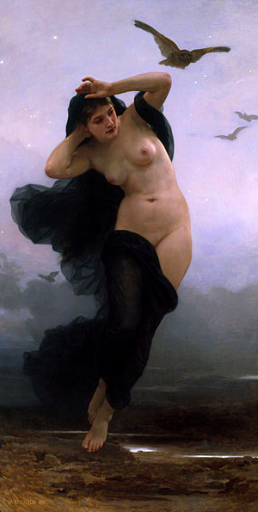
[The Demiurge] before undertaking the entire creative task is said to enter the oracular shrine of Night to fill himself with divine thoughts from there, to receive the principles of the creative task and, if it is permissible to speak thus, to resolve all difficulties and above all to encourage his father [Kronos] to collaborate with him in the creative task. This is what he is recorded as saying by the Theologian in his poem: Mother, supreme among the gods, immortal Night, how, tell me, How should I establish a resolute beginning for the immortals? And from her he hears: Surround all things with unutterable ether, and in the middle place heaven./And he is then instructed about the remainder of the creative work. See also in Tim., I 206.28-207.20, I 314.1-25, I 315.14, I 324.26, II 24. 25-31, II 256.20 and III 102.1-6 for explicit reference to this advice.
How might I interpret Asklepigenia through Lorde’s erotic, Trask’s transmission of cultural history from one person to another in things like ritual or Lugones’ “world”-traveling, e.g. understanding the honor/responsibility/authority of the sole keeper of the sacred theurgic rites in the Neoplatonic Academy? Furthermore, insofar as Iamblichean/Procline Platonism radically practiced a form of theurgy based in Chaldean/Orphic lore that not merely featured the power of the feminine but centralized it in the goddess Night, how might it inform us of the concrete teachings of priestesses from within this late Platonic tradition? Did they help inspire a feminizing movement that put focus back on the Mother of the Gods?
La Nuit by Bougeureau 1893

